
Viewed by:
Philippe POHER
Tel.: +33 (0)2 99 27 92 92
E-mail: philippe.poher@iwedia.com

Written by:
Philippe POHER
Tel.: +33 (0)2 99 27 92 92
E-mail: philippe.poher@iwedia.com
IWEDIA

TKEL Technical Specifications

V2.0

Approved by:
Thierry GARNIER
Tel.: +33 (0)2 99 27 92 92
E-mail: thierry.garnier@iwedia.com

SUMMARY
1 Reference documents 4
2 Documentation History 5
3 Introduction 6
4 Module Overview and Architecture 7
4.1 Definitions, Acronyms and Abbreviations 7
4.2 General Description 8
4.2.1 TKEL Definition 8
4.2.2 Critical Sections 8
4.2.3 Event Definition 9
4.2.4 Queue Definition 9
4.2.5 Timer Definition 9
4.2.6 Interactions with other TDAL modules 9
4.3 Architecture 10
4.4 TKEL API Description 11
4.4.1 Generic Interface 11
4.4.2 Task Management Interface 11
4.4.3 Task Synchronisation Interface 12
4.4.4 Task Communication 12
4.4.5 Memory Management 12
4.4.6 Timer Management 13
5 TKEL API Specification 14
5.1 Type Specifications 14
5.1.1 Generic 14
5.1.2 Types to define by the implementation 14
5.2 TKEL API Usage 15
5.2.1 Task menagment 15
5.2.2 Synhronization 18
5.2.3 Queues 19
5.3 TKEL Macro/Define/Enum/Typedef/Structure Definitions 19
5.3.1 Define Definitions 19
5.3.1.1 kTKEL_TIMEOUT_XXX 20
5.3.1.2 ms2tick 20
5.3.1.3 tick2ms 20
5.3.2 Enum Definitions 21
5.3.2.1 TKEL_err 21
5.3.2.2 TKEL_status 22
5.3.3 Typedef Definitions 22
5.3.4 Structure Definitions 23
5.3.4.1 TKEL_timer_CB 23
5.4 TKEL API Functions 24
5.4.1 Generic Interface API 24
5.4.1.1 TKEL_Init(-) 24
5.4.1.2 TKEL_Term(-) 25
5.4.1.3 TKEL_Abort(-) 26
5.4.1.4 TKEL_GetTick(-) 27
5.4.1.5 TKEL_EnterIT(-) 28
5.4.1.6 TKEL_ExitIT(-) 29
5.4.2 Task Management Interface API 30
5.4.2.1 TKEL_CreateTask(-) 30
5.4.2.2 TKEL_DeleteTask(-) 31
5.4.2.3 TKEL_GetTaskPriority(-) 32
5.4.2.4 TKEL_SetTaskPriority(-) 33
5.4.2.5 TKEL_GetCurrentTask(-) 34
5.4.2.6 TKEL_SuspendTask(-) 35
5.4.2.7 TKEL_ResumeTask(-) 36
5.4.2.8 TKEL_DelayTask(-) 37
5.4.2.9 TKEL_CreateSemaphore(-) 38
5.4.2.10 TKEL_DeleteSemaphore(-) 39
5.4.2.11 TKEL_SignalSemaphore(-) 40
5.4.2.12 TKEL_WaitSemaphore(-) 41
5.4.2.13 TKEL_WaitSemaphoreTimeout(-) 42
5.4.2.14 TKEL_Critical(-) 43
5.4.2.15 TKEL_Normal(-) 44
5.4.3 Synchronisation task 45
5.4.3.1 TKEL_SendEvent(-) 45
5.4.3.2 TKEL_SendITEvent(-) 46
5.4.3.3 TKEL_ReceiveEvent(-) 47
5.4.3.4 TKEL_ResetEvent(-) 48
5.4.3.5 TKEL_CreateMutex(-) 49
5.4.3.6 TKEL_DeleteMutex(-) 50
5.4.3.7 TKEL_LockMutex(-) 51
5.4.3.8 TKEL_UnlockMutex(-) 52
5.4.3.9 TKEL_TryLockMutex(-) 53
5.4.4 Task Communication 54
5.4.4.1 TKEL_CreateQueue(-) 54
5.4.4.2 TKEL_CreateQueueTimeout(-) 55
5.4.4.3 TKEL_DeleteQueue(-) 56
5.4.4.4 TKEL_Enqueue(-) 57
5.4.4.5 TKEL_Dequeue(-) 58
5.4.4.6 TKEL_EnqueueTimeout(-) 59
5.4.4.7 TKEL_DequeueTimeout(-) 60
5.4.4.8 TKEL_GetMsgNumber(-) 61
5.4.4.9 TKEL_NotifyQueueEvent(-) 62
5.4.5 Memory management 63
5.4.5.1 TKEL_GetMemoryPartition(-) 63
5.4.5.2 TKEL_Malloc(-) 64
5.4.5.3 TKEL_Free(-) 65
5.4.5.4 TKEL_CreateFixedSizeMemPart(-) 66
5.4.5.5 TKEL_DeleteMemPart(-) 67
5.4.5.6 TKEL_MemPartAlloc(-) 68
5.4.5.7 TKEL_MemPartFree(-) 69
5.4.5.8 TKEL_MemPartCheckBuffer(-) 70
5.4.6 Timer manegement 71
5.4.6.1 TKEL_CreateTimer(-) 71
5.4.6.2 TKEL_DeleteTimer(-) 72
5.4.6.3 TKEL_StartTimer(-) 73
5.4.6.4 TKEL_StartTimerWithCB(-) 74
5.4.6.5 TKEL_StopTimer(-) 75
5.4.6.6 TKEL_SetTimerOwnerTask(-) 76
6 TDAL_DMX External Dependencies 77
6.1.1.1 TKEL_timer_CB 77

Reference documents
The following documents were used to write this specification:

Document | Version | Title

Documentation History

History
Vers. | Date | Nature
1 | 30/08/2001 | Draft
1.2 | 17/11/2004 | TKEL_SetTimerOwnerTask added.
1.3 | 18/11/2004 | Add TKEL_CreateQueueTimeout, TKEL_EnqueueTimeout, TKEL_DequeueTimeout, TKEL_GetMemoryPartition, TKEL_StartTimerWithCB and TKEL_GetTick
2.0 | 10/01/2008 | Relook of documentation
2.1 | 7/02/2008 | Add TKEL_SetTimerOwnerTask in new version of document

Introduction
The purpose of this document is to specify the interface and to describe the internal design of the Thin KernelEncapsulation Layer for Operationg system[TKEL]. The aim of this module is to provide a complete interface between middlewares and the operating system of a set-top-box.

Module Overview and Architecture

Definitions, Acronyms and Abbreviations
CHAL | Comedia hardware Adaptation Layer, composed of TDALs driver, TKEL and TBOX module
TDAL | Thin Driver Adaptation Layer
TKEL | Thin Kernel Encapsulation Layer
TBOX | Tool Box
OS | Operating System
RTOS | Real Time Operating System
ISR | Interrupt Service Routine

General Description
The main job of the TKEL API is to offer a geneic interface for the comedia middleware for operting system call.
The TKEL module must manage a memory pool used by the comedia middleware for dynamic memory allocation.

TKEL Definition
The TKEL services offered are:
- Task management, priority range [0-128] (0 lower, 128 high)
- Task synchronization (semaphores, critical regions, events): standard use of semaphore, critical sections, mutex and events objects.
- Task communications (queues): standard use of queue FIFO message.
- Memory management: The API enables the client to create a specific partition with fixed size buffers and manages such buffers allocation. The client may also allocate buffer (with different sizes) in the common TKEL partition.
- Timer management: At least the TKEL modules may the client to create 50 Timers enabled at the same time.

Critical Sections
A critical section is used to lock the scheduler in order to make sure that no preemption will occur between its beginning and its end.
Critical sections can be nested, and each beginning must have a corresponding end. The execution status prior to the beginning of a critical region must be stored in a local variable to be restored at the end.

Event Definition
Each task has 32 event flags it can wait on, bit-wise encoded in a 32-bit word. Each of the 32 bits can be defined as an event flag for application-specific purposes. The definition of the events is the responsibility of the programmer.
A task or ISR can send one or more events to another task. If the target task is not
waiting, the event bit(s) are simply turned on, which makes the events pending. If the
target task is waiting, then the task is unblocked and made ready-to-run.
Events are neither queued nor counted. For example, if three identical events are sent to a task before it issues a wait for that event, the three events have the same effect as one event.

Queue Definition
Queues only support fixed length messages. The length of the messages must be specified at the creation.

Timer Definition
A timer sends events upon expiration of the timer interval to the task which starts it. The events must be encoded into bits 0 – 15. The task must call TKEL_ReceiveEvent to receive any timer-triggered events.
A timer created with a callback call the callback at the expiration, in this cse no event is associated to the event.

Interactions with other TDAL modules
The TDAL modules must not use the TKEL APIs and memory pool allocation.

Architecture
The figure below shows the relation between the client module and the low level drivers:

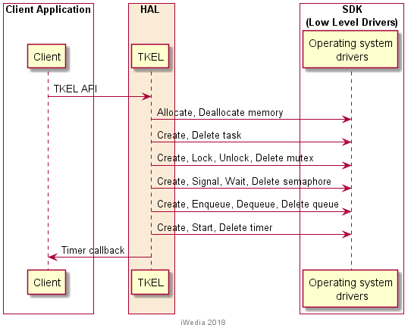

TKEL API Description

Generic Interface
The generic interface allows clients to control the TKEL module.
This interface is used with the following functions:
- TKEL_Init(-) in order to initialize the TKEL module.
- TKEL_Term(-) in order to terminate the TKEL module.
- TKEL_EnterIT(-) in order to enter under interrupt service routine. This function is currently not used by the clients.
- TKEL_ExitIT(-) in order to esit from interrupt service routine. This function is currently not used by the clients.
- TKEL_Abort(-) in order to abort a process. Only used in DEBUG.
- TKEL_GetTick(-) in order to get number ticks per seconds of the platform
- ms2tick(-) in order to convert ms value into ticks value
- tick2ms(-) in order to convert ticks value into ms value

Task Management Interface
- TKEL_CreateTask(-) in order to create a task.
- TKEL_DeleteTask(-) in order to delete a task
- TKEL_GetTaskPriority(-) in order to get the priority of the task
- TKEL_SetTaskPriority(-) in order to set a priority to a task
- TKEL_GetCurrentTask(-) in order to get current task Id
- TKEL_SuspendTask(-) in oder to suspend the current task
- TKEL_ResumeTask(-) in order to resume a task
- TKEL_DelayTask(-) in order to delay task processing
- TKEL_CreateSemaphore(-) in order to create a semaphore
- TKEL_DeleteSemaphore(-) in order to delete a semaphore
- TKEL_SignalSemaphore(-) in order to signal a semaphore
- TKEL_WaitSemaphore(-) in order to wait semahore
- TKEL_WaitSemaphoreTimeout(-) in order to wait semaphore with timeout
- TKEL_Critical(-) in order to enter in critical section
- TKEL_Normal(-) in order to leave critical section.

Task Synchronisation Interface
- TKEL_SendEvent(-) in order to send event to a task
- TKEL_SendITEvent(-) in order to send an event from interrupt task to target task.
- TKEL_ReceiveEvent(-) in order to get an event for a task
- TKEL_ResetEvent(-) in order to reset the event bitmask of a task
- TKEL_CreateMutex(-) in order to create a mutex
- TKEL_DeleteMutex(-) in order to delete a mutex
- TKEL_LockMutex(-) in order to take a mutex
- TKEL_UnlockMutex(-) in order to release a mutex
- TKEL_TryLockMutex(-) in order to try to take a mutex without blocking call it is already taken by another task.

Task Communication
- TKEL_CreateQueue(-) in order to create a FIFO queue.
- TKEL_CreateQueueTimeout(-) in order to create a queue with a timeout for the call to TKEL_EnqueueTimeout(-) and TKEL_DequeueTimeout(-).
- TKEL_DeleteQueue(-) in order to delete a queue
- TKEL_Enqueue(-) in order to enqueue a message
- TKEL_Dequeue(-) in order to get a message from the queue
- TKEL_EnqueueTimeout(-) in order to enqueue message with timeout
- TKEL_DequeueTimeout(-) in order to get message with timeout
- TKEL_GetMsgNumber(-) in order to get message number in queue
- TKEL_NotifyQueueEvent(-) in order to transform an event as a message.

Memory Management
- TKEL_GetMemoryPartition(-) in order to get TKEL memory partition handle.
- TKEL_Malloc(-) in order to get a buffer in TKEL partition.
- TKEL_Free(-) in order to free a buffer in TKEL partition.
- TKEL_CreateFixedSizeMemPart(-) in order to create a fixed buffer partition.
- TKEL_DeleteMemPart(-) in order to delete a fixed memory partition.
- TKEL_MemPartAlloc(-) in order to allocate buffer in fixed buffer partition.
- TKEL_MemPartFree(-) in order to free a buffer in fixed buffer partition.
- TKEL_MemPartCheckBuffer(-) in order to check a buffer has been allocated in fixed buffer partition.

Timer Management
- TKEL_CreateTimer(-) in order to create a timer object.
- TKEL_DeleteTimer(-) in order to delete a timer object
- TKEL_StartTimer(-) in order to start a created timer
- TKEL_StartTimerWithCB(-) in order to stop a created timer
- TKEL_StopTimer(-) in order to stop a created timer
- TKEL_SetTimerOwnerTask(-) in order to change task owner of the timer.

TKEL API Specification

Type Specifications

Generic

TKEL_err defines the enum values for error found in TKEL functions
TKEL_status defines the enum value to set the state of the critical section for a processing.

Types to define by the implementation

The following types must be defined by a private include mapped on OS ported on the platform.

TKEL_int8, TKEL_int16, TKEL_int32, TKEL_uint8, TKEL_uint16, TKEL_uint32, TKEL_bool, TKEL_msize, TKEL_frame, TKEL_cause, TKEL_prio, TKEL_evts, TKEL_task_id, TKEL_sema_id, TKEL_mutex_id, TKEL_queue_id, TKEL_qdepth, TKEL_qwidth, TKEL_memPart_id, TKEL_tck.

TKEL_prio: priority of a task (range value 0 (lower priority) -127(high priority).

As a consequence, the private include which defines these types must be include at the beginning of TKEL.h

TKEL API Usage
In order to activate TKEL API for task menagment, memory menagment and synchronization it is necessary to initialize it.
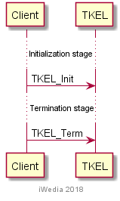
Figure 1 Initialize TKEL

Task menagment
Following diagram presents call sequence for creating and maintain task life-time. It is possible to set task priority dynamically at run-time.
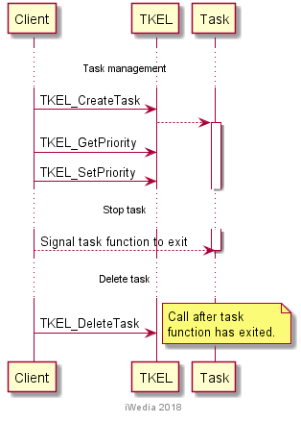
Figure 2 Task Management – Setting priority
It is possible to delete task from within the task function, but it has to be last statement in the function, before function exits. Next diagram gives this workflow.

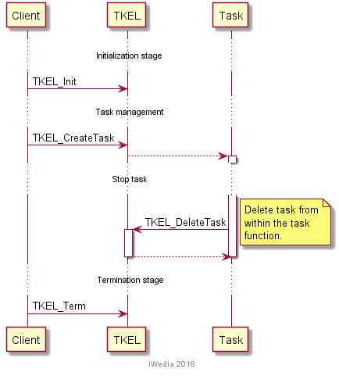
Figure 3 Task management – Self distruction
There is support for critical section execution in TKEL. If task enters critical section, all other tasks are suspended, until task exits critical section.

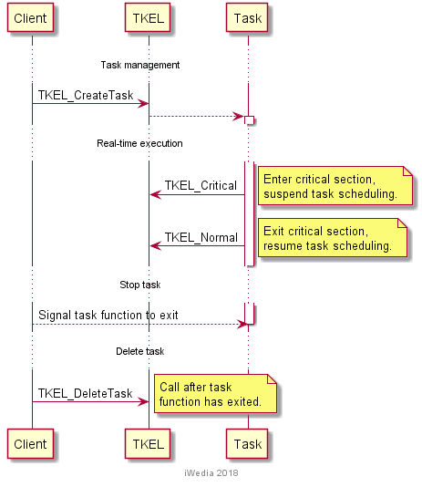
Figure 4 Task management – Critical section
It is possible to pause task execution from within the task and from outside world. Next diagram gives those two cases.

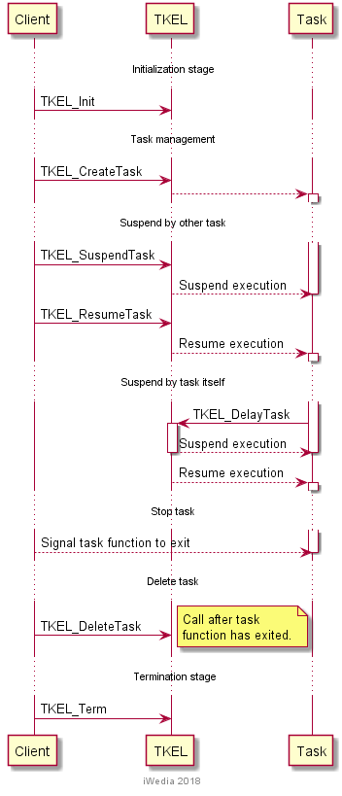
Figure 5 Task management – Suspend task execution
In case of self suspention, task can only suspend its execution for limited amount of time.

Synhronization
Support for synchronization is available with mutexes and semaphores. Following diagrams show use cases for both.
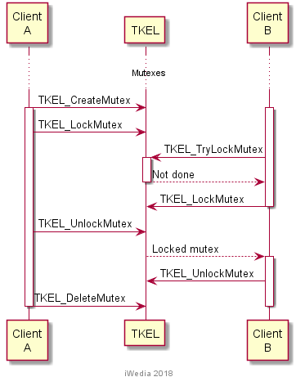
Figure 6 Mutexes

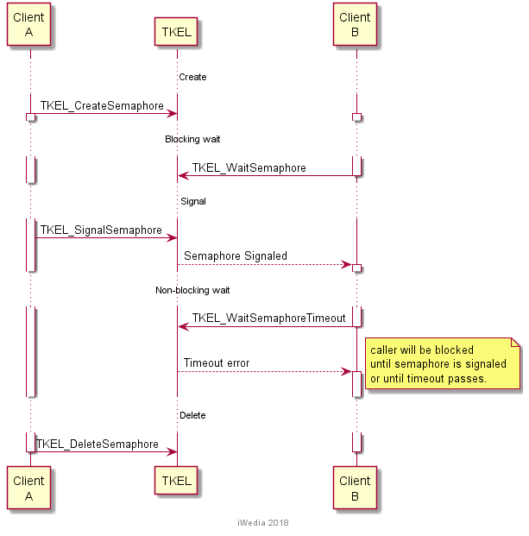
Figure 7 Semaphores

Queues
Support for queues is available in two forms, blocking and non-blocking queues. Following diagram gives example of blocking queue and two tasks exchanging messages using it.
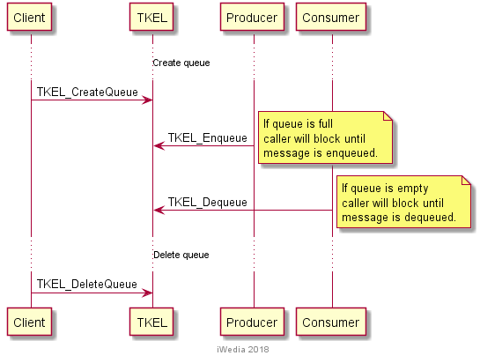
Figure 8 Create and use blocking queue

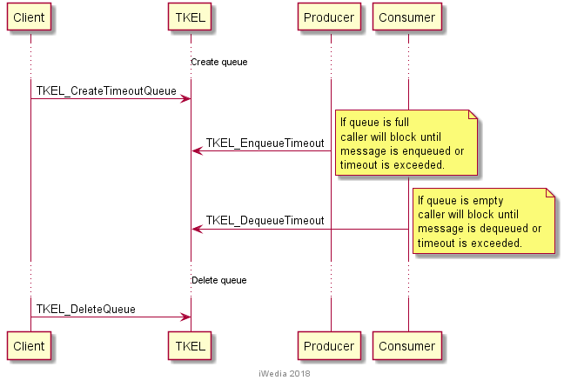
Figure 9 Create and use non-blocking queue
It is also possible to create and delete queues by either producer or consumer task.

TKEL Macro/Define/Enum/Typedef/Structure Definitions

Define Definitions

kTKEL_TIMEOUT_XXX
These constant are used to define the timeout value timeout INFINITY, IMMEDIATE
#define kTKEL_TIMEOUT_INFINITE 0
#define kTKEL_TIMEOUT_IMMEDIATE 1

ms2tick
This macro is used to convert milliseconds into number of ticks.
Must be define by private include

tick2ms
This macro is used to convert ticks into milliseconds.
Must be define by private include

Enum Definitions

TKEL_err
An enumeration of the different possible error value handled by TKEL.
typedef enum
{
TKEL_NO_ERR, /* No error. */
TKEL_TIMEOUT, /* A timeout occurred. */
TKEL_BAD_ARG, /* Wrong argument value(s). */
TKEL_NOT_DONE /* Command not done. */
} TKEL_err;

TKEL_status
An enumeration of the different possible status fro critical section

typedef enum
{
TKEL_NORMAL, /* Normal execution. */
TKEL_CRITICAL /* Critical region. */
} TKEL_status;

Typedef Definitions
None.

Structure Definitions

TKEL_timer_CB
This typedef defines the TKEL callback type registered by the client to receive timer notification.
typedef void (*TKEL_timer_CB) ();

Parameters:
None

TKEL API Functions

Generic Interface API

TKEL_Init(-)
Prototype:
TKEL_err TKEL_Init (void);
Description:
This function initialises the TKEL module. It creates the TKEL partition.
Return value:
It returns TKEL_NO_ERROR if initialization succeed.

Parameters:
None.
Comments:
This function must be called before any other functions of the TKEL API.
See Also:
TKEL_Term(-).

TKEL_Term(-)
Prototype:
TKEL_err TKEL_Term (void);
Description:
This function terminates the TKEL module.
Return value:
It returns TKEL_NO_ERROR if termination succeed.

Parameters:
None.
Comments:
Any function of TKEL API should not be called after TKEL_Terminate(-) call.
See Also:
TKEL_Init(-).

TKEL_Abort(-)
Prototype:
void TKEL_Abort(TKEL_cause cause);
Description:
This function ends the processing for an error cause.
Use only in DEBUG purpose.
Return value:
None

Parameters:
Parameter | Type | Dir | Description
cause | TKEL_cause | In | Cause of the abort

Comments:
This function can be called at any time the TKEL has been initialised with TKEL_Init(-) but not after the termination with TKEL_Term(-).
See Also:

TKEL_GetTick(-)
Prototype:
TKEL_err TKEL_GetTick(TKEL_tck *pTick);
Description:
This function enables to get the number of ticks of the platform.
Return value:
It returns TKEL_NO_ERROR if termination succeed.

Parameters:
Parameter | Type | Dir | Description
cause | TKEL_cause | In | Cause of the abort

Comments:
This function can be called at any time the TKEL has been initialised with TKEL_Init(-) but not after the termination with TKEL_Term(-).
See Also:

TKEL_EnterIT(-)
Prototype:
TKEL_frame TKEL_EnterIT(TKEL_frame frame); /* Enter an Interrupt Service Routine. */
Description:
Enter an Interrupt Service Routine.

The stack frame parameter is a pointer to the stack frame of the interrupted context, if provided by the OS actually used.
Return value:
It returns the stack frame.

Parameters:
Parameter | Type | Dir | Description
cause | TKEL_cause | In | Cause of the abort

Comments:
This function can be called at any time the TKEL has been initialised with TKEL_Init(-) but not after the termination with TKEL_Term(-).
See Also:

TKEL_ExitIT(-)
Prototype:
TKEL_frame TKEL_ExitIT(TKEL_frame frame); /* Exit an Interrupt Service Routine. */
Description:
Exit the current Interrupt Service Routine.

The stack frame parameter is a pointer to the stack frame of the highest priority task in the “Ready List”, if provided by the OS actually used

Return value:
It returns the stack frame.

Parameters:
Parameter | Type | Dir | Description
cause | TKEL_cause | In | Cause of the abort

Comments:
This function can be called at any time the TKEL has been initialised with TKEL_Init(-) but not after the termination with TKEL_Term(-).
See Also:

Task Management Interface API

TKEL_CreateTask(-)
Prototype:
TKEL_err TKEL_CreateTask (
TKEL_prio priority, /* Creates and starts a task. */
char *taskName,
TKEL_int16 stackSize,
void (*entry) (void*),
void *arg,
TKEL_task_id *taskId );

Description:
This function creates a task with a stack size given in parameter.

Return value:
It returns TKEL_NO_ERROR if task creation is succeeded.
Parameters:
Parameter | Type | Dir | Description
priority | TKEL_prio | In | Priorty of the task [0;128]
taskName | char * | In | taskName string
stackSize | TKEL_int16 | In | Stack size of the task to create
entry | void (*entry) (void*) | In | Entry point of the task
arg | void * | In | Argument iof entry point
taskId | TKEL_task_id * | Out | Task identifier
Comments:
This function can be called at any time the TKEL has been initialised with TKEL_Init(-) but not after the termination with TKEL_Term(-).
See Also:

TKEL_DeleteTask(-)
Prototype:
TKEL_err TKEL_DeleteTask(TKEL_task_id taskID); /* Deletes a task. */
Description:
This function deletes a task created
Return value:
It returns TKEL_NO_ERROR if the action succeeds.
Parameters:
Parameter | Type | Dir | Description
taskID | TKEL_task_id | In | Task identifier
Comments:
This function can be called at any time the TKEL has been initialised with TKEL_Init(-) but not after the termination with TKEL_Term(-).
See Also:

TKEL_GetTaskPriority(-)
Prototype:
TKEL_err TKEL_GetTaskPriority
(TKEL_task_id taskID, /* Gets a task's priority. */
TKEL_prio *priority);
Description:
This function retrieves a task priority
Return value:
It returns TKEL_NO_ERROR if the action succeeds.
Parameters:

Parameter | Type | Dir | Description
taskID | TKEL_task_id | In | Task identifier
priority | TKEL_prio | Out | Priority of the task

Comments:
If the value of taskID is NULL, the priority of the current running task is gotten.

This function can be called at any time the TKEL has been initialised with TKEL_Init(-) but not after the termination with TKEL_Term(-).
See Also:

TKEL_SetTaskPriority(-)
Prototype:
TKEL_err TKEL_SetTaskPriority
(TKEL_task_id taskID, /* Changes a task's priority. */
TKEL_prio priority);
Description:
This function sets task priority to a task
Return value:
It returns TKEL_NO_ERROR if the action succeeds.

Parameters:

Parameter | Type | Dir | Description
taskID | TKEL_task_id | In | Task identifier
priority | TKEL_prio | In | Priority of the task

Comments:
If the value of taskID is NULL, the priority of the current running task is changed.

This function can be called at any time the TKEL has been initialised with TKEL_Init(-) but not after the termination with TKEL_Term(-).
See Also:

TKEL_GetCurrentTask(-)
Prototype:
TKEL_err TKEL_GetCurrentTask(TKEL_task_id *taskID); /* Get the ID of the current running task. */
Description:
This function retrieves the Id of the current task.
Return value:
It returns TKEL_NO_ERROR if the action succeeds.
Parameters:
Parameter | Type | Dir | Description
taskID | TKEL_task_id | Out | Task identifier
Comments:
This function can be called at any time the TKEL has been initialised with TKEL_Init(-) but not after the close of the termination with TKEL_Term(-).
See Also:

TKEL_SuspendTask(-)
Prototype:
TKEL_err TKEL_SuspendTask(void);
Description:
This function suspends the current task.
Return value:
It returns TKEL_NO_ERROR if the action succeeds.

Parameters:
None
Comments:
This function can be called at any time the TKEL has been initialised with TKEL_Init(-) and but not after the termination with TKEL_Term(-).

See Also:

TKEL_ResumeTask(-)
Prototype:
TKEL_err TKEL_ResumeTask(TKEL_task_id taskID); /* Resumes a task. */
Description:
This function resumes the suspended task.
Return value:
It returns TKEL_NO_ERROR if the action succeeds.
Parameters:
Parameter | Type | Dir | Description
taskID | TKEL_task_id | In | Task identifier

Comments:

This function can be called at any time the TKEL has been initialised with TKEL_Init(-) and but not after the termination with TKEL_Term(-).

See Also:

TKEL_DelayTask(-)
Prototype:
TKEL_err TKEL_DelayTask(TKEL_tck ticks); /* Suspends the current running task for a period of time. */
Description:
This function deschedules a task for a defined time.
Return value:
It returns TKEL_NO_ERROR if the action succeeds.
Parameters:
Parameter | Type | Dir | Description
ticks | TKEL_tck | In | Number of ticks for descheduling time

Comments:

This function can be called at any time the TKEL has been initialised with TKEL_Init(-) and but not after the termination with TKEL_Term(-).

See Also:

TKEL_CreateSemaphore(-)
Prototype:
TKEL_err TKEL_CreateSemaphore
(TKEL_int16 count, /* Creates a semaphore. */
TKEL_sema_id *semaphoreID);
Description:
This function creates a semaphore according to a initial token count
Return value:
It returns TKEL_NO_ERROR if the action succeeds.
Parameters:
Parameter | Type | Dir | Description
count | TKEL_int16 | In | Initial token count
semaphoreID | TKEL_sema_id | Out | Semaphore identifier

Comments:

This function can be called at any time the TKEL has been initialised with TKEL_Init(-) and but not after the termination with TKEL_Term(-).

See Also:

TKEL_DeleteSemaphore(-)
Prototype:
TKEL_err TKEL_DeleteSemaphore(TKEL_sema_id semaphoreID); /* Deletes a semaphore. */
Description:
This function deletes a semaphore.
Return value:
It returns TKEL_NO_ERROR if the action succeeds.
Parameters:
Parameter | Type | Dir | Description
semaphoreID | TKEL_sema_id | In | Semaphore identifier

Comments:

This function can be called at any time the TKEL has been initialised with TKEL_Init(-) and but not after the termination with TKEL_Term(-).

See Also:

TKEL_SignalSemaphore(-)
Prototype:
TKEL_err TKEL_SignalSemaphore(TKEL_sema_id semaphoreID); /* Releases a semaphore token. */
Description:
This function releases a semaphore token.
Return value:
It returns TKEL_NO_ERROR if the action succeeds.
Parameters:
Parameter | Type | Dir | Description
semaphoreID | TKEL_sema_id | In | Semaphore identifier

Comments:

This function can be called at any time the TKEL has been initialised with TKEL_Init(-) and but not after the termination with TKEL_Term(-).

See Also:

TKEL_WaitSemaphore(-)
Prototype:
TKEL_err TKEL_WaitSemaphore(TKEL_sema_id semaphoreID); /* Acquires a semaphore token. */
Description:
This function takes a semaphore token.
Return value:
It returns TKEL_NO_ERROR if the action succeeds.
Parameters:
Parameter | Type | Dir | Description
semaphoreID | TKEL_sema_id | In | Semaphore identifier

Comments:

This function can be called at any time the TKEL has been initialised with TKEL_Init(-) and but not after the termination with TKEL_Term(-).

See Also:

TKEL_WaitSemaphoreTimeout(-)
Prototype:
TKEL_err TKEL_WaitSemaphoreTimeout(TKEL_sema_id semaphoreID, TKEL_tck ticks);
/* Acquires a semaphore token. */
Description:
This function takes a semaphore token with a defined timeout
Return value:
It returns TKEL_NO_ERROR if the action succeeds.
Parameters:
Parameter | Type | Dir | Description
semaphoreID | TKEL_sema_id | In | Semaphore identifier
ticks | TKEL_tck | In | Number of ticks for timeout

Comments:

This function can be called at any time the TKEL has been initialised with TKEL_Init(-) and but not after the termination with TKEL_Term(-).

See Also:

TKEL_Critical(-)
Prototype:
TKEL_err TKEL_Critical(TKEL_status *status); /* Begins a critical region. */
Description:
This function begins a critical section for the current task.
Return value:
It returns TKEL_NO_ERROR if the action succeeds.
Parameters:
Parameter | Type | Dir | Description
status | TKEL_status | In | Status

Comments:
This routine disables the scheduling.
This function can be called at any time the TKEL has been initialised with TKEL_Init(-) and but not after the termination with TKEL_Term(-).

See Also:

TKEL_Normal(-)
Prototype:
TKEL_err TKEL_Normal(TKEL_status status); /* Ends a critical region. */
Description:
This function begins a critical section.
Return value:
It returns TKEL_NO_ERROR if the action succeeds.
Parameters:
Parameter | Type | Dir | Description
status | TKEL_status | In

Comments:
Ends a critical region. Restores the execution status.
This routine re-enables the scheduling.

This function can be called at any time the TKEL has been initialised with TKEL_Init(-) and but not after the termination with TKEL_Term(-).

See Also:

Synchronisation task

TKEL_SendEvent(-)
Prototype:
TKEL_err TKEL_SendEvent
(TKEL_task_id taskID, /* Sends events to a target task. */
TKEL_evts events);
Description:
This function sends an event to target task identified by tasked.
The event must be encoded into bits 0 – 31, understood by the target task.
Return value:
It returns TKEL_NO_ERROR if the action succeeds.
Parameters:
Parameter | Type | Dir | Description
taskID | TKEL_task_id | In | Task identifier
events | TKEL_evts | In | Event definition to send

Comments:

This function can be called at any time the TKEL has been initialised with TKEL_Init(-) and but not after the termination with TKEL_Term(-).

See Also:

TKEL_SendITEvent(-)
Prototype:
TKEL_err TKEL_SendITEvent
(TKEL_task_id taskID, /* Sends events from an IT to a target task. */
TKEL_evts events);
Description:
This function sends an event to target task identified by tasked from an in terrupt processing.
The event must be encoded into bits 0 – 31, understood by the target task.
Return value:
It returns TKEL_NO_ERROR if the action succeeds.
Parameters:
Parameter | Type | Dir | Description
taskID | TKEL_task_id | In | Task identifier
events | TKEL_evts | In | Event definition to send

Comments:

This function can be called at any time the TKEL has been initialised with TKEL_Init(-) and but not after the termination with TKEL_Term(-).

See Also:

TKEL_ReceiveEvent(-)
Prototype:

TKEL_err TKEL_ReceiveEvent
(TKEL_tck ticks, /* Receives events */
TKEL_evts *events);
Description:
This function enables the current task to receive event for a defined time.
Return value:
It returns TKEL_NO_ERROR if the action succeeds.
Parameters:
Parameter | Type | Dir | Description
ticks | TKEL_tck | In | Time definition in number of ticks
events | TKEL_evts * | Out | Event list received

Comments:
If the value of timeout is 0, TKEL_ReceiveEvent() waits indefinitely.
Events are encoded into bits 0 – 31. Timer-triggered events are encoded into bits 0 – 15.
Events are reset after a call to this function.

This function can be called at any time the TKEL has been initialised with TKEL_Init(-) and but not after the termination with TKEL_Term(-).

See Also:

TKEL_ResetEvent(-)
Prototype:

TKEL_err TKEL_ResetEvent(void); /* Resets the pending events. */
Description:
This function enables the current task to reset the pending events associated to the current running task
Return value:
It returns TKEL_NO_ERROR if the action succeeds.
Parameters:
None
Comments:

This function can be called at any time the TKEL has been initialised with TKEL_Init(-) and but not after the termination with TKEL_Term(-).

See Also:

TKEL_CreateMutex(-)
Prototype:

TKEL_err TKEL_CreateMutex(TKEL_mutex_id * MutexID);
Description:
This function enables the client to create a mutex
Return value:
It returns TKEL_NO_ERROR if the action succeeds.
Parameters:
Parameter | Type | Dir | Description
MutexID | TKEL_mutex_id * | Out | Mutex identifier

Comments:

This function can be called at any time the TKEL has been initialised with TKEL_Init(-) and but not after the termination with TKEL_Term(-).

See Also:

TKEL_DeleteMutex(-)
Prototype:
TKEL_err TKEL_DeleteMutex(TKEL_mutex_id MutexID);
Description:
This function enables the client to delete a mutex
Return value:
It returns TKEL_NO_ERROR if the action succeeds.
Parameters:
Parameter | Type | Dir | Description
MutexID | TKEL_mutex_id | In | Mutex identifier

Comments:

This function can be called at any time the TKEL has been initialised with TKEL_Init(-) and but not after the termination with TKEL_Term(-).

See Also:

TKEL_LockMutex(-)
Prototype:
TKEL_err TKEL_DeleteMutex(TKEL_mutex_id MutexID);
Description:
This function enables the client to lock a mutex.
If the mutex is locked by another task, the current task is suspended.

Return value:
It returns TKEL_NO_ERROR if the action succeeds.
Parameters:
Parameter | Type | Dir | Description
MutexID | TKEL_mutex_id | In | Mutex identifier

Comments:

This function can be called at any time the TKEL has been initialised with TKEL_Init(-) and but not after the termination with TKEL_Term(-).

See Also:

TKEL_UnlockMutex(-)
Prototype:
TKEL_err TKEL_UnlockMutex(TKEL_mutex_id MutexID);
Description:
This function enables the client to unlock a mutex.
If the mutex is waited for by another task, this suspended task is resumed.

Return value:
It returns TKEL_NO_ERROR if the action succeeds.
Parameters:
Parameter | Type | Dir | Description
MutexID | TKEL_mutex_id | In | Mutex identifier

Comments:

This function can be called at any time the TKEL has been initialised with TKEL_Init(-) and but not after the termination with TKEL_Term(-).

See Also:

TKEL_TryLockMutex(-)
Prototype:
TKEL_err TKEL_TryLockMutex(TKEL_mutex_id MutexID);
Description:
This function enables the client to try to lock a mutex.
If the mutex is locked by another task, this function exits with the return value TKEL_NOT_DONE. Otherwise the mutex is locked.

Return value:
It returns TKEL_NO_ERROR if the action succeeds.
Parameters:
Parameter | Type | Dir | Description
MutexID | TKEL_mutex_id | In | Mutex identifier

Comments:

This function can be called at any time the TKEL has been initialised with TKEL_Init(-) and but not after the termination with TKEL_Term(-).

See Also:

Task Communication

TKEL_CreateQueue(-)
Prototype:
TKEL_err TKEL_CreateQueue
(TKEL_qdepth maxNumber, /* Creates a message queue. */
TKEL_qwidth msgSize,
TKEL_queue_id *queueID);
Description:
This function enables the client to create a queue

Return value:
It returns TKEL_NO_ERROR if the action succeeds.
Parameters:
Parameter | Type | Dir | Description
maxNumber | TKEL_qdepth | In | Max number of message of the queue
msgSize | TKEL_qwidth | In | Maximum message size
queueID | TKEL_queue_id * | Out | Queue Id

Comments:

This function can be called at any time the TKEL has been initialised with TKEL_Init(-) and but not after the termination with TKEL_Term(-).

See Also:

TKEL_CreateQueueTimeout(-)
Prototype:
TKEL_err TKEL_CreateQueueTimeout
(TKEL_qdepth maxNumber, /* Creates a message queue with timeout. */
TKEL_qwidth msgSize,
TKEL_queue_id *queueID);
Description:
This function enables the client to create a queue managing timeouts.

Return value:
It returns TKEL_NO_ERROR if the action succeeds.
Parameters:
Parameter | Type | Dir | Description
maxNumber | TKEL_qdepth | In | Max number of message of the queue
msgSize | TKEL_qwidth | In | Maximum message size
queueID | TKEL_queue_id * | Out | Queue Id

Comments:

This function can be called at any time the TKEL has been initialised with TKEL_Init(-) and but not after the termination with TKEL_Term(-).

See Also:

TKEL_DeleteQueue(-)
Prototype:
TKEL_err TKEL_DeleteQueue(TKEL_queue_id queueID); /* Deletes a message queue. */
Description:
This function enables the client to delete a message queue.

Return value:
It returns TKEL_NO_ERROR if the action succeeds.
Parameters:
Parameter | Type | Dir | Description
queueID | TKEL_queue_id | In | Queue Id

Comments:

This function can be called at any time the TKEL has been initialised with TKEL_Init(-) and but not after the termination with TKEL_Term(-).

See Also:

TKEL_Enqueue(-)
Prototype:
TKEL_err TKEL_Enqueue
(TKEL_queue_id queueID, /* Posts a message to a queue. */
void *message);
Description:
This function enables the client to enqueue a message in a queue.

Return value:
It returns TKEL_NO_ERROR if the action succeeds.
Parameters:
Parameter | Type | Dir | Description
queueID | TKEL_queue_id | In | Queue Id
message | Void * | In | Message Buffer

Comments:
If the queue is locked by another task, the current running task is suspended until the queue is unlocked.

This function can be called at any time the TKEL has been initialised with TKEL_Init(-) and but not after the termination with TKEL_Term(-).

See Also:

TKEL_Dequeue(-)
Prototype:
TKEL_err TKEL_Dequeue
(TKEL_queue_id queueID, /* Requests a message from a queue. */
void *message);
Description:
This function enables the client to dequeue a message from a queue.

Return value:
It returns TKEL_NO_ERROR if the action succeeds.
Parameters:
Parameter | Type | Dir | Description
queueID | TKEL_queue_id | In | Queue Id
message | Void * | Out | Message Buffer get from the queue

Comments:
If the queue is empty, the current running task is suspended until a message is posted.

This function can be called at any time the TKEL has been initialised with TKEL_Init(-) and but not after the termination with TKEL_Term(-).

See Also:

TKEL_EnqueueTimeout(-)
Prototype:
TKEL_err TKEL_EnqueueTimeout
(TKEL_queue_id queueID, /* Posts a message to a queue. */
void *message,
TKEL_tck ticks);
Description:
This function enables the client to dequeue a message from a queue with a defined timeout. The queue must have been created by TKEL_CreateQueueTimeout(-).

Return value:
It returns TKEL_NO_ERROR if the action succeeds.
Parameters:
Parameter | Type | Dir | Description
queueID | TKEL_queue_id | In | Queue Id
message | Void * | Out | Message Buffer get from the queue
ticks | TKEL_t | In | Timeout for the action

Comments:
If the queue is locked by aother task, the current running task is suspended until the message is posted.

This function can be called at any time the TKEL has been initialised with TKEL_Init(-) and but not after the termination with TKEL_Term(-).

See Also:

TKEL_DequeueTimeout(-)
Prototype:
TKEL_err TKEL_DequeueTimeout
(TKEL_queue_id queueID, /* Requests a message from a queue. */
void *message,
TKEL_tck ticks);
Description:
This function enables the client to enqueue a message in a queue in a defined time. The queue must have been created by TKEL_CreateQueueTimeout(-).

Return value:
It returns TKEL_NO_ERROR if the action succeeds.
Parameters:
Parameter | Type | Dir | Description
queueID | TKEL_queue_id | In | Queue Id
message | Void * | Out | Message Buffer get from the queue
ticks | TKEL_tck | In | Timeout for the action

Comments:
If the queue is empty, the current running task is suspended until the timeout expired.

This function can be called at any time the TKEL has been initialised with TKEL_Init(-) and but not after the termination with TKEL_Term(-).

See Also:

TKEL_GetMsgNumber(-)
Prototype:
TKEL_err TKEL_GetMsgNumber
(TKEL_queue_id queueID, /* Gets the number of message in a queue. */
TKEL_int16 *msgNumber);
Description:
This function enables the client to get the number message in a defined queue.

Return value:
It returns TKEL_NO_ERROR if the action succeeds.
Parameters:
Parameter | Type | Dir | Description
queueID | TKEL_queue_id | In | Queue Id
msgNumber | TKEL_int16 | Out | Number of messages in the queue

Comments:

This function can be called at any time the TKEL has been initialised with TKEL_Init(-) and but not after the termination with TKEL_Term(-).

See Also:

TKEL_NotifyQueueEvent(-)
Prototype:
TKEL_err TKEL_NotifyQueueEvent
(TKEL_queue_id queueID,
TKEL_task_id taskID,
TKEL_evts events);
Description:
Associate an event with a queue.
TKEL_NotifyQueueEvent registers a task and a set of events to notify of message arrival at the message queue. Whenever a message arrives at the queue an event of the registered type will be posted to the registered task by means of the TKEL event mechanism. Subsequent calls will replace the registered task and/or set of events by other tasks and/or set of events. The notification can be turned off by setting the expected event to 0 by using the same call.The notification call can be used to wait for multiple queues simultaneously. To wait for multiple queues, call TKEL_NotifyQueueEvent on each queue, then wait for the event with TKEL_ReceiveEvent. After receiving the event, retrieve the message with TKEL_Dequeue.
Return value:
It returns TKEL_NO_ERROR if the action succeeds.
Parameters:
Parameter | Type | Dir | Description
queueID | TKEL_queue_id | In | Queue Id
taskID | TKEL_task_id | In | Identifier of the target task
events | TKEL_evts | In | Events to send

Comments:

This function can be called at any time the TKEL has been initialised with TKEL_Init(-) and but not after the termination with TKEL_Term(-).

See Also:

Memory management

TKEL_GetMemoryPartition(-)
Prototype:
void* TKEL_GetMemoryPartition(void);
Description:
Returns the handle on TKEL partition
Return value:
It returns the handle on TKEL partition.
Parameters:
None
Comments:

This function can be called at any time.
See Also:

TKEL_Malloc(-)
Prototype:
TKEL_err TKEL_Malloc
(TKEL_msize memorySize,
void **buffer); /* Allocates a memory buffer. */
Description:
This function enables the client to allocate a buffer in TKEL partition.

Return value:
It returns TKEL_NO_ERROR if the action succeeds.
Parameters:
Parameter | Type | Dir | Description
memorySize | TKEL_msize | In | Size of the buffer to allocate
buffer | Void ** | Out | Buffer address

Comments:

This function can be called at any time the TKEL has been initialised with TKEL_Init(-) and but not after the termination with TKEL_Term(-).

See Also:

TKEL_Free(-)
Prototype:
TKEL_err TKEL_Free(void *buffer); /* Releases a memory buffer. */
Description:
This function enables the client to free a buffer in TKEL partition.

Return value:
It returns TKEL_NO_ERROR if the action succeeds.
Parameters:
Parameter | Type | Dir | Description
buffer | Void * | In | Buffer address

Comments:

This function can be called at any time the TKEL has been initialised with TKEL_Init(-) and but not after the termination with TKEL_Term(-).

See Also:

TKEL_CreateFixedSizeMemPart(-)
Prototype:
TKEL_err TKEL_CreateFixedSizeMemPart
( /* Creates a memory partition. */
TKEL_uint32 bufferSize,
TKEL_uint32 memPartSize,
void* memPartAddress,
TKEL_memPart_id *memPartID);
Description:
This function enables the client to free a buffer in TKEL partition.

Return value:
It returns TKEL_NO_ERROR if the action succeeds.
Parameters:
Parameter | Type | Dir | Description
bufferSize | TKEL_uint32 | In | Size of the buffers defined for a specific partition
memPartSize | TKEL_uint32 | In | Size of the partition with fixed buffer
memPartAddress | Void * | Out | Start Address of the partition
memPartID | TKEL_memPart_id * | Out | Id of the fixed buffer partition

Comments:

This function can be called at any time the TKEL has been initialised with TKEL_Init(-) and but not after the termination with TKEL_Term(-).

See Also:

TKEL_DeleteMemPart(-)
Prototype:
TKEL_err TKEL_DeleteMemPart(
TKEL_memPart_id memPartID); /* Deletes a memory partition. */
Description:
This function enables the client to free a fixed buffer partition.

Return value:
It returns TKEL_NO_ERROR if the action succeeds.
Parameters:
Parameter | Type | Dir | Description
memPartID | TKEL_memPart_id | In | Partition identifier

Comments:

This function can be called at any time the TKEL has been initialised with TKEL_Init(-) and but not after the termination with TKEL_Term(-).

See Also:

TKEL_MemPartAlloc(-)
Prototype:
TKEL_err TKEL_MemPartAlloc( /* Allocates a memory buffer. */
TKEL_memPart_id memPartID,
TKEL_msize memorySize,
void **buffer);
Description:
This function enables the client to allocate a buffer in a fixed buffer memory partition.

Return value:
It returns TKEL_NO_ERROR if the action succeeds.
Parameters:
Parameter | Type | Dir | Description
memPartID | TKEL_memPart_id | In | Partition identifier
memorySize | TKEL_msize | In | Memory size to allocate
buffer | Void ** | Out | Buffer address

Comments:

This function can be called at any time the TKEL has been initialised with TKEL_Init(-) and but not after the termination with TKEL_Term(-).

See Also:

TKEL_MemPartFree(-)
Prototype:
TKEL_err TKEL_MemPartFree( /* Releases a memory buffer. */
TKEL_memPart_id memPartID,
void *buffer);
Description:
This function enables the client to free a buffer in a fixed buffer memory partition.

Return value:
It returns TKEL_NO_ERROR if the action succeeds.
Parameters:
Parameter | Type | Dir | Description
memPartID | TKEL_memPart_id | In | Partition identifier
buffer | Void * | In | Buffer address to free

Comments:

This function can be called at any time the TKEL has been initialised with TKEL_Init(-) and but not after the termination with TKEL_Term(-).

See Also:

TKEL_MemPartCheckBuffer(-)
Prototype:
TKEL_err TKEL_MemPartCheckBuffer( /* Check a memory buffer. */
TKEL_memPart_id memPartID,
void *buffer);
Description:
This function enables the client to check if a buffer has been allocated in a fixed buffer memory partition.

Return value:
It returns TKEL_NO_ERROR if the action succeeds.
Parameters:
Parameter | Type | Dir | Description
memPartID | TKEL_memPart_id | In | Partition identifier
buffer | Void * | In | Buffer address to check

Comments:

This function can be called at any time the TKEL has been initialised with TKEL_Init(-) and but not after the termination with TKEL_Term(-).

See Also:

Timer manegement

TKEL_CreateTimer(-)
Prototype:
TKEL_err TKEL_CreateTimer(TKEL_timer_id *timerID); /* Creates a timer. */
Description:
This function enables the client to check if a buffer has been allocated in a fixed buffer memory partition.

Return value:
It returns TKEL_NO_ERROR if the action succeeds.
Parameters:
Parameter | Type | Dir | Description
timerID | TKEL_timer_id * | Out | Timer Identifier

Comments:

This function can be called at any time the TKEL has been initialised with TKEL_Init(-) and but not after the termination with TKEL_Term(-).

See Also:

TKEL_DeleteTimer(-)
Prototype:
TKEL_err TKEL_DeleteTimer(TKEL_timer_id timerID); /* Deletes a timer. */
Description:
This function enables the client to delete a created timer.

Return value:
It returns TKEL_NO_ERROR if the action succeeds.
Parameters:
Parameter | Type | Dir | Description
timerID | TKEL_timer_id * | in | Timer Identifier

Comments:

This function can be called at any time the TKEL has been initialised with TKEL_Init(-) and but not after the termination with TKEL_Term(-).

See Also:

TKEL_StartTimer(-)
Prototype:
TKEL_err TKEL_StartTimer( TKEL_timer_id timerID, /* Starts a timer. */
TKEL_tck ticks,
TKEL_evts events);
Description:
This function enables the client to start a timer with event notification.

Return value:
It returns TKEL_NO_ERROR if the action succeeds.
Parameters:
Parameter | Type | Dir | Description
timerID | TKEL_timer_id * | in | Timer Identifier
ticks | TKEL_tck | In | Value of the timer
events | TKEL_evts | In | Events to send when the timer is fallen

Comments:
The events must be encoded into bits 0 – 15.

This function can be called at any time the TKEL has been initialised with TKEL_Init(-) and but not after the termination with TKEL_Term(-).

See Also:

TKEL_StartTimerWithCB(-)
Prototype:
TKEL_err TKEL_StartTimerWithCB
( TKEL_timer_id timerID, /* Starts a timer with callback on timeout */
TKEL_tck ticks,
TKEL_timer_CB callback);
Description:
This function enables the client to start a timer with callback notification management.

Return value:
It returns TKEL_NO_ERROR if the action succeeds.
Parameters:
Parameter | Type | Dir | Description
timerID | TKEL_timer_id * | in | Timer Identifier
ticks | TKEL_tck | In | Value of the timer
callback | TKEL_timer_CB | In | Callback to call when timer has fallen

Comments:

This function can be called at any time the TKEL has been initialised with TKEL_Init(-) and but not after the termination with TKEL_Term(-).

See Also:

TKEL_StopTimer(-)
Prototype:
TKEL_err TKEL_StopTimer(TKEL_timer_id timerID); /* Stops a timer. */
Description:
This function enables the client to stop a timer.

Return value:
It returns TKEL_NO_ERROR if the action succeeds.
Parameters:
Parameter | Type | Dir | Description
timerID | TKEL_timer_id * | in | Timer Identifier
ticks | TKEL_tck | In | Value of the timer
callback | TKEL_timer_CB | In | Callback to call when timer has fallen

Comments:

This function can be called at any time the TKEL has been initialised with TKEL_Init(-) and but not after the termination with TKEL_Term(-).

See Also:

TKEL_SetTimerOwnerTask(-)
Prototype:
TKEL_err TKEL_SetTimerOwnerTask
(TKEL_timer_id timerID,
TKEL_task_id taskID); /* Set the Owner of the timer. */
Description:
The default owner of the timer is the task which has created and started the timer.
The Owner may be change by TKEL_SetTimerOwnerTask call.
Set the Owner task of the timer, which will receive the event, when the timeout is expired.

If TimerID is wrong or taskID is NULL, the TKEL_BAD_ARG is returned.

Return value:
It returns TKEL_NO_ERROR if the action succeeds.
Parameters:
Parameter | Type | Dir | Description
timerID | TKEL_timer_id * | in | Timer Identifier
taskID | TKEL_task_id | In | New owner of the timer

Comments:

This function can be called at any time the TKEL has been initialised with TKEL_Init(-) and but not after the termination with TKEL_Term(-).

See Also:

TDAL_DMX External Dependencies

TKEL_timer_CB
This type defines the call-back prototype that a client must give to TKEL so it can be notified timer is fallen.
Prototype:
typedef void (*TKEL_timer_CB) ();

Return value:
None.
Parameters:
None
Comments:
None.
See Also:

